The Heaviness of Waiting
July 6, 2016
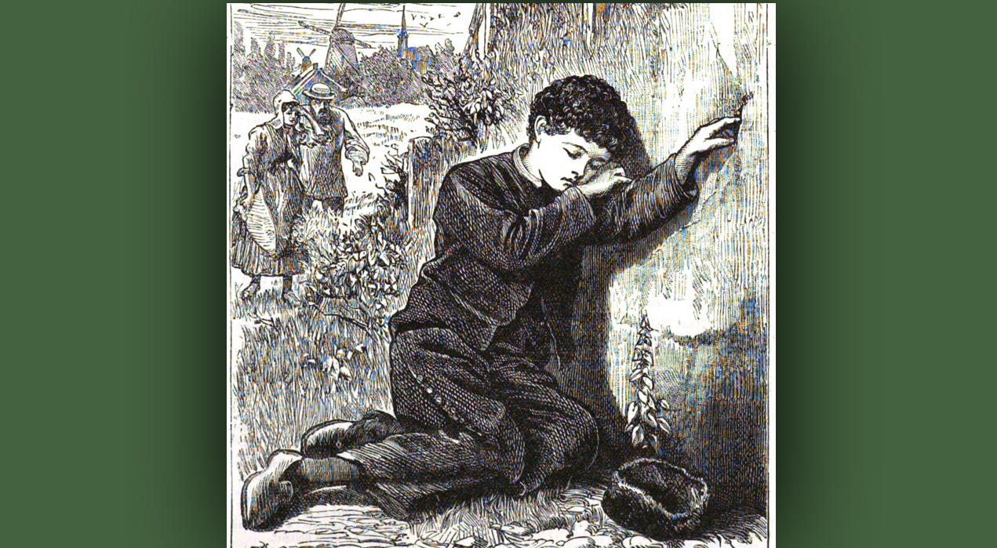
The precious presence of Our Lord Jesus be your comfort, Heartdwellers.

After worship time today, the Lord approached me very tenderly and sincerely. Looking into my eyes, He began, “It’s been a little rough going hasn’t it, My Bride?”

Yes, Lord…and I’ve been calling on You to do it constantly, as You well know - and it’s still been hard.

“That’s the nature of the beast, My Love. Even when you call upon Me to do things, there is still a price to pay for being the conduit of My Love and words to our precious family. But you are well seasoned in this area, and we get through it, don’t we?” He looked at me plaintively.

I suppose. A little worse for wear, but yes, here we are. My Jesus, what is on Your heart tonight.

He began, "Waiting. The heaviness of waiting, seeing My Brides assaulted by so many lies, doubts, attacks and watching them hold up under it. Yes, I see your heart, for you it has gotten to the point of sorrow and pain. I’m sorry for this, Clare, but I am using it…have you ever known Me to let you down?"

Well, there are still unfulfilled things I am waiting for, but I assume they are after our return… And in other things You have been amazingly faithful, I have to trust You, Lord. You’ve accomplished so many more miracles. Everyday is a new miracle as I see things coming to pass in our personal life.

I’m sorry I feel this way, Jesus. I am just tired.

"Like that butterfly you found…it was spent, it had worn itself out, its wings were frayed and it could barely move them anymore. But I renew you, Clare. I draw you into My bosom and renew you, Sweet Spouse. And you will carry on until the very last moment…the very last drop. This perseverance is one of your hallmarks, one of the gifts I have given you. Most would have given up a long time ago. But you have persevered.

"I see the dagger in your heart over this waiting; I see it, I know it, I feel it with you. Don’t suppose for a moment I am not suffering as you are. Yes, I am suffering this and even more as I see My children for the last time, as they are taken to Hell because of their obstinate denial of Me. They are exiled and never more shall I be comforted by the joy of their laughter. No, now it is bitter regrets, screams and groaning, which I, as God, cannot ignore. There is a chamber in My heart where the voices of Hell call out to Me. I cannot escape it. It is My creation and it is oh, so painful, nerve-wracking and shattering. But it is there, and I am continuously aware of it.

"Put your head on My shoulder and rest here. Just rest for a few moments.
"Clare, there is nothing to say, except that I feel the very same way. I share your grief, your waiting, your weariness, all of it. I carry it with you and for you."

Yes, Lord, please help me carry this burden. Please help me. The longing is breaking my heart. But my intellect puts it down, because I know how high the stakes are . I know I am numb to the tremendous suffering of others around the world.

"Well, you think you are numb, but in fact, much of what you carry is associated with their burdens. I have distributed this burden to souls all around the globe, that others may not totally collapse it. I wish I could do more to alleviate this pain, I wish I could. That is why you have a puppy and kitties and companions, and even your life-mate to share all these things with. I would never leave you without some consolations.

"You will find comfort in meditating on the Stations of the Cross. You will find comfort and strength in My suffering. Yes, you will find it. Everyone is feeling this burden, Clare. This burden of waiting, whether they recognize it or not. It is built into their everyday experience. Some are aware that it is something very large outside of themselves that they are carrying. For them, it is but a shadow; something intangible, associated also with apprehension.

"But this dynamic has been a part of their lives for so long, it is not even limited to recent events in the world. We have been near nuclear wars many, many times - too many times to count. But My Father did not give the word and it was averted. What you are partaking of now is something Christians have been feeling since the 60’s. Had My Father allowed it then, you and I would not be together now... so you can see how the delays have impacted so many souls."

Lord, what can I do to bring relief to those who are suffering in this exile, who are waiting? I myself am so weak and feeble at this point, surely there must be something.

He replied, "I cannot tell you soon, you already know that. Besides you have heard it and you are still here."

Well, that’s the thing. One visionary says it is 15-17 years away. Is she right?

"No, Clare. She is not right. There is no way it is going to last that long."

Forgive me, Lord, but if You do not know the day or hour, how can you say that with surety?

"The season. The season is well past it’s prime, and that is because we are trying to avert the worst sufferings mankind can imagine. There are things being set in motion now that will mitigate events and allow more and more to survive and even be saved.

"Imagine a very long dyke, holding back an entire lake filled with every kind of unclean thing."

By the way, guys - a dyke is like a low dam, rather than a great big, tall, hefty dam. It's a long cement abutment that holds backwater. It's not anywhere near as large as a dam. And it can go for a very long distance.

He continued, "Imagine a very long dyke, holding back an entire lake filled with every kind of unclean thing. Down river are many homes, playgrounds, schools; places that are full of life. And this dyke is growing old, developing cracks along its surface. When a crack develops, a soul comes along and puts their finger in to hold back the deluge that would surely kill the inhabitants downstream.

"Since the 60’s, this dyke has been ready to give way, but concerned and responsible citizens have come and placed their fingers in the holes, holding it back from giving out. Many have rallied to the cause of preventing disaster, but the dyke continues to develop cracks and time is running out. Now the foundation is giving way and water is beginning to leak out at their feet as well. The dirt has turned to mud and is slippery, and despite all the best efforts to hold that water back, there is a tipping point where the ground will give way and nothing more can be done. The dyke will burst and all downstream will be washed away.

"That is the point we are at right now. Water is seeping out from underneath, those holding back the cracks are losing their footing as the earth beneath them turns to slippery mud. In some places, the earth is still dry. But in others, the water is beginning to form rivulets and turn everything around it into mud.

"If this is any comfort to you, this is the stage we are at now. Concerned citizens, prayer warriors, have continued to hold it back, but soon there will be nothing more they can do.

"When that tipping point comes, there will be breakaway points in different places along the dyke, and as they give way, the rest will follow. We are at the muddy stage now, people are losing their footing, small streams are forming while in other places that were dry, water is seeping out at the bottom.

"Tell My People their deliverance will come suddenly and without warning. That is why I have taken all this time to prepare you, so that you will stand when others collapse. You cannot envision the changes that will take place, but you can cultivate your total reliance on Me and I will see you through.

"Intimacy with Me is key. Knowing My voice and obeying My wishes, is key. This is where your deliverance lies: in your cleaving to Me and following the path laid out for you. My people, I know you are painfully weary in waiting and I see how you have sacrificed and supported Me as we gather as many as we can and your faithfulness will be richly rewarded.

"In the meantime, be faithful to what I have appointed you to do. And if you do not have an appointed work, go about doing good to your neighbor. Forgive others, be kind to your enemies, take care of those around you who cannot care for themselves. Pray for them. Worship and pursue a deeper relationship with Me. I will not disappoint you, and your reward shall be great.

"Persevere, My Beautiful people. Persevere."

